

INTERNATIONAL CONFERENCE

PROCESS  
MANAGEMENT AND

SCIENTIFIC  
DEVELOPMENTS

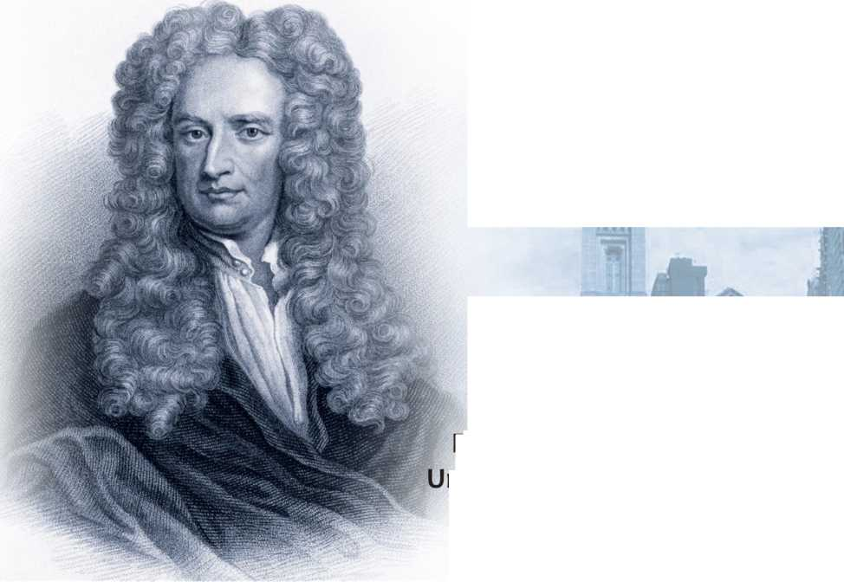

Birmingham lited Kingdom

Proceedings of the International Conference

"Process Management and Scientific Developments’

[Birmingham, Urited Kingdom, November 24,2021].. Pan 2

**MG?**

ISBN 970-5-905695-32-2 (print]

ISBN 979-0-ЙБ295М-5 [online]

Thesa CcnferencE Proceedings combine materials cf the conference - research papers **and** thesis reports of scientific workers. They examines tecnical and sociological issues of research issues. Some articles deal with theoretical and methodological approaches and principles of research questions of personality professionalization.

Authors are responsible for the accuracy of cited publ'cations, facts, figures, quotaticns, statistics, proper names and other information.

©Scientific publishing house Infinity, 2021 ©AUS PUBLISHERS, 2021

©Group of authors, 2 02J

DOI 10.3466 O/l NF.2021.11.51.015

UDO 165.9

**ASTRONOMICAL STRUCTURE** OIF **SOME SIGNS IN ROCK  
PAINTINGS** OF **THE SHULGAN TASH CAVE (KAPOVA) AMD THEIR  
CULTURAL PARALLELS**

**Polyakova Olga Olegovna**

Postgraduate

Nosov Magnitogorsk State Technical University **Scientific adviser: Zhilina Vera Anatolyevna** Doctor **of** Philological Sciences, Associate Professor Nosov Magnitogc rsk State Technical University

**Abstract** *Ever since intelligent humanity began to plan its economic activities, calculating h ow much reserves need to be saved for the winter in order to feed the tribe, people have already followed the seasons with the help of luminaries and planets against the background of stars. The lunar calendar* **was** *enough for hunters and gatherers if they knew the constel­lations and observed the moon in them. The stars were inaccessible to touch, so the constellations were inscribed with signs and endowed with divine images, in contrast to the drawings of real animals. Divine, too, was the center of the ecliptic system, the Pole of the Ecliptic., which in the North­ern Hemisphere of the starry sky is always located next to the “head" of the constellation Draco. This constellation acquired the image of the Dragon in very ancient times, so ancient that it can be traced in ail details among the Chinese., among the American Indians who crossed the Bering Bridge before 10 thousand BC, in the Shulgan Tash (Kapova) cave.*

*Keywords: Dragon, Moon, calendar, Pole of the Ecliptic, Mother of the World, Deer.*

Ever since intelligent mankind began to plan its economic activities, calculating how much reserves need to be saved for the winter in order to feed the tribe, people have already followed the seasons with the help of luminaries and planets. And in this, Ноппо-sapiens (intelligent **man)** dif­**fered** from **animals,** which, perhaps, noticed the luminaries of the **Sun and** the **Mooi, but** only on **a** sensory level, in such qualities as warm-cold, light­dark. White hunters and gatherers moved after herds and did not have a permanent residence, it was difficult to track the constant places of sunrise

and sunset in the daytime, but against the background of the night sky with the Moon and planets, one could observe their path among the stars in any locality. Therefore, at first, lunar calendars appeared in everyday life, which divided the lunar path along the Ecliptic into constellations - lunar sites. Such a lunar calendar, **not** tied to a specific locality, was enough **for** hunter-gatherers if they knew the lunar sites on the ecliptic and observed the **Moon in them.** The **moon** rose and set relative to the horizon, evok­ing dual associations among ancient people: birth-death, light-darkness, good-evil, which, in **tum,** gave rise to the first naive explanations of the dual materialistic laws **of** nature **in** the minds **of** ancient people.

The stars were inaccessible to touch, therefore the constellations in caves, on dishes, **in** the ornamentation of clothing were inscribed with signs and endowed with inaccessible **divine** images, **in** contrast to the nat­**uralistic** drawings of real arimals. Divine was also the center **of** the ecliptic, the Pole of the Ecliptic, which in the Northern Hemisphere of the starry sky is always located next to the1 head" of the constellation Draco. The Pole of the Ecliptic, due to the lunar characteristics, was often endowed **with** the divine symbols of the Mother of the World, who is responsible for birth and death, light and darkness, good and evil - like the moon and planets ris­ing and setting in the night sky. In many myths, legends and religions, the Serpent or the Dragon is one of the main characters, as, for example, in the Old Testament, the Serpent lived in paradise on the Tree of Good and Evil, who seduced Eve to eat the apple of sin. In the Indian Rig Veda, the Vritra Serpent was the main deity of the asura gods, with whom the solar Indra **fought.** In Slavic, Scandinavian, Germanic tales, one of the main characters is the Dragon, with which the goodies are fighting.

This constellation acquired the image of the Serpent or Dragon in very ancient times. How ancient these times were, we can judge by the fact that the symbols of the Dragon pass through the cultures of the Eurasian peoples and among the American Indians. It is known that the ancestors of the American Indians in waves left Siberia along the Bering Bridge, which existed before 10 thousand БС, until it was washed away by the waters of the Bering Strait, formed as a result of ice melting at the end of the last ice age. The first day of the most ancient Mayan calendar system in America is the day **"ImistT,** depicted in the form of the head of the Serpent-Dragon. "The deity **Imish** is a crocodile ora dragon. In addition, this is a **kind** of **ma­**ternal essence, symbolizing in all myths, without exception, the primordial principle of the world, canying everything into the world that it is inhab­ited. Imish teaches us to comprehend the relationship between life and death, the interaction of masculine and feminine principles - everything in

Я1

which we are used to seeing the "struggle of opposites" [1]. This idea of the Serpent-Dragon, the foremother of the world and the struggle of opposites remained in Siberia, obviously, in some **kind** of Proto-Indo-European com­**munity** of people, which later spread throughout the continent of Eurasia.

Cosmic symbols are tenacious, because they were observed daily by ancient people in the sky. The divine images of the Serpent and the Bird, as Proto-llndo-European symbols among the Altai tribes, have also been preserved among the American Indians. They depicted their sun god Quet­zalcoatl as a Biird holding a Serpent in its beak (Fig. 1 a). The Chinese also have similar images of the Dragon-Serpent (Fig. 1 b>, whose nation was formed from numerous tribes, including the Altai ones [Reshetov et al., Chinese], Curves of Indian Serpents and Chinese Dragons are directed in the same direction, counterclockwise - just as they are located in the starry sky in the constellation Draco (Fig. 2).

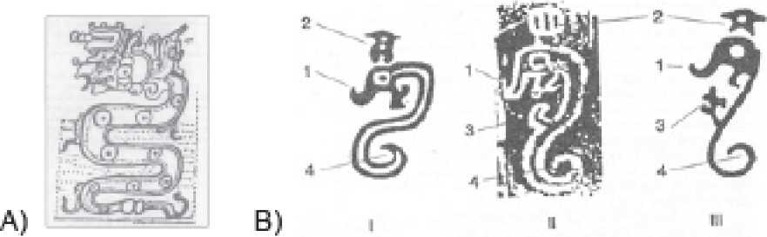

Fig. 1. A) The Indian symbol of the Snake and Quetzalcoatl [2, p.

96]. B) Chinese symbols of Dragons [3, p. 24].

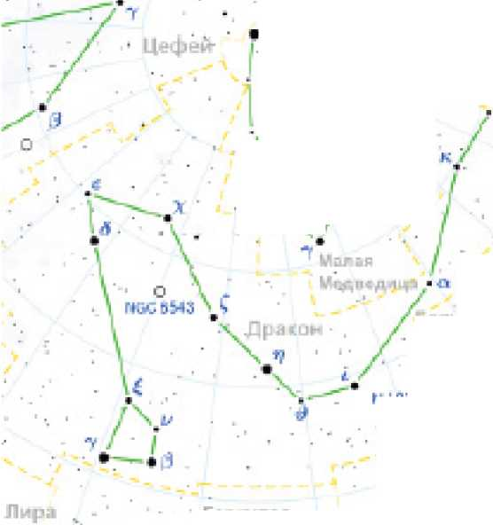

*J*

A

Cl*

\ ■ ■ ■

■ tn vCZ

Копьшаи

Г/ IQt u 1 O’1

**Fig. 2. Constellation Dragon in the northern hem**

**isphere of the starry sky.**

**Above the 'head11 of the**

**Dragon constellation Lyra [4]**

Above the "head" of the constellation Draco is the star Vega, alpha of the constellation Lyra, one **of** the brightest stars **in** the northern hemi­sphere of the sky, which was the Pole Star near the Pole of the World 14 thousand years ago. Perhaps the Bird Quetzalcoatl, a solar deity among the American Indians, and the Star over the head of the Dragon among the Chinese - these were the images of the Pole **Star** Vega, **alpha** Lyra, next to the "head" of the constellation Draco.

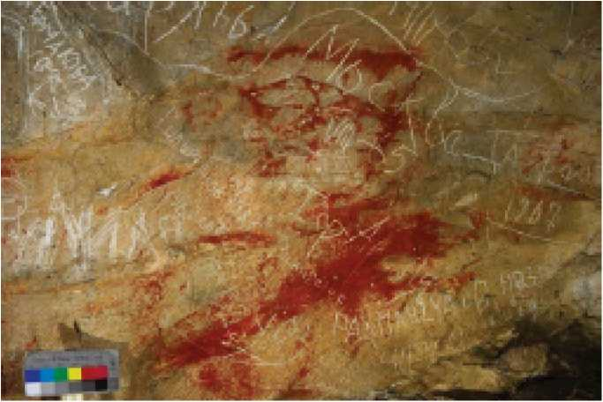A similar celestial constellation Dragon is the sign "Dragon" **in** the Shulgan Tash (Kapova) cave, identified among many other drawings as a result of many years of exploration of the cave since their discovery by the biologist of the Bashkir Reserve A.V. Ryumin in 1959, continued by the research of the Moscow archaeologist O.N. Bader from 1960 to 1978, then, by the Leningrad archaeologist V.E. Shchelinsky from 1982 to 1999, and further, speleologists of the Russian Geographical Society under the leadership of the candidate of geological and mineralogical sciences of the A. P. Karpinsky Russian Geological Research Institute (VSEGEI), **Yu.S.** Lyakhnitsky. The invaluable work "Drawings and Signs of the Shul- **gan** Tash (Kapova} cave. Catalog of images", published in **Ufa in** 2013, where the authors **Yu.**S. Lyakhnitsky, O.A. Minnikov, A. A. Yushko gave the most detailed descriptions of the drawings, with their exact reference to the cardinal points [5]. It is this circumstance that allows us, researchers of ancient knowledge, to look for the correspondence of some drawings to the arrangement of constellations in the sky in certaiin ancient eras. The drawings were made at different times, starting from the 14th millennium BC. Anciient people chose the ceilings of caves and grottoes **in** order to show celestial signs above their heads as accurately as possible on their spherical surface. The most accurate correspondence to the starry sky is the composition of signs **with** the ‘'Dragon"' **in** the Niche of the Domed Hlall

and the constellation Dragon (Fig. 3).

**Fig. 3. Figure 3-9 "Dragon" and sign 3-10 "Ancient trapezium" in the Niche of the Dome**

**Hall [5. p. 110]**

B6 ||

Apparently, it is no coincidence that the researchers of the Shulgan Tash **(Kapova)** cave called the "tailed" drawing Dragon, because the Dragon is **a** very ancient archetype and passes through the mythologies of many peo­ples, evoking dragon associations in our contemporaries when looking at this drawing, although an ordinary lizard could have looked the same way. Then the **"Ancient** trapezium" located **in** the **last** bend of the "Dragon's" tail above its "head" is the constellation Ursa Minor, the "ladle" of which sug­gested that it corresponded to a certain box or trapezoid. Trapezium im­ages are often found in the drawings of the Shulgan Tash (Kapova} cave. Perhaps the trapeziums symbolized the quadrangles, which are in some constellations of the northern hemisphere of the starry sky: in the Ursa Major and Ursa Minor, Hercules, Perseus, Cepheus, Andromeda, Raven, Chalice.

The joint composition of the constellations Dragon and Ursa Minor, one might say, is eternal in the circumpolar picture of the northern starry sky, only the position of the Pole of the World relative to these constellations changes. **On** the plan of the Nishi of the Domed **Hall** [Ibid. p. 10D] (Fig. 4), together **with** the scheme for linking images **in** the Niche of the Dome Hall [Ibid, p. 101] (Fig. 5), we notice that signs 3-9 "Dragon" and 3-10 "Ancient trapezium" are located in the northwestern part of the Niche of the Dome Hall, south of a certain central position of a tubular dead-end branch and sign 3-12 "Arkhar" in it.

Let us dare to assume that the Pole of the World, located north and below the constellation Draco, was placed in the central position of the tubular dead-end branch by the ancient people, and even further north and below on the central meridian could be the star Vega, alpha of the constel­lation Lyra.

The approximate position of the constellations in the desired epoch can be determined by hitting a sign in the cave, if you plot the section of the Nishi of the Dome Hall at latitudes from CP to 90° - into 9 strips of 10* each (Fig. 5).

As a result, we see that the sign "Dragon" falls **at about** 50э, the sign "Ancient trapezium" at 60“, and the Pole of the World is between them at 53", which corresponds to the geographical latitude of the Shulgan Tash **(Kapova)** cave **of** 53° N.

S7

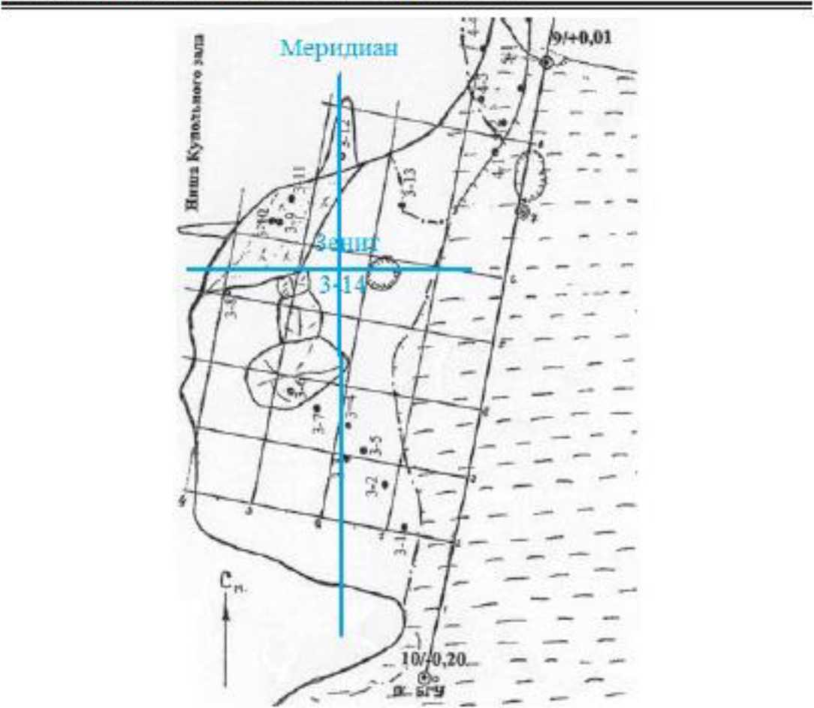

Fig. 4. Top view of the Niches of the Domed Hall (after Lyakhnitsky et al., P. 100) with the indicated position of the numbered signs. Light blue - author’s markup.

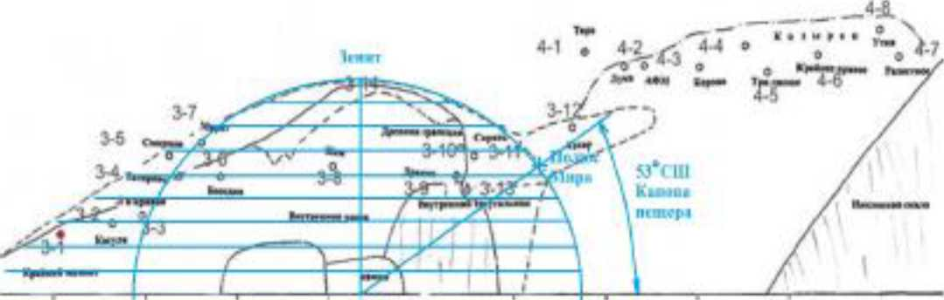

Fig. 5. Niche of the domed hall (after Lyakhnitsky et al., P. 101).

Dividing the panel with numbered signs in the Niche of the Dome Hall into latitudes from 0° to 90° in strips of 10°. Light blue - author’s markup.

with other stars of the "shoulder” of the constellation Hercules. The Pole of the World is projected between the signs "Sireyat” and "Inner Triangle" Hercules is occupied by the star Vega, alpha Lyrae, one of the brightest stars in the northern hemisphere of the starry sky.

To the southwest of the composition with the Dragon, Ursa Minor, Her­cules, Pole of Peace and Vega is the constellation Ursa Major - this can be seen at the top left on the star map (Fig 6), where the south is above the Pole of the World, towards the zenith - the higher, the further south, because this star map is viewed north and further south overhead. In Fig­ure 4, we see that in the southern half of the Nishi hall, from northwest to southeast, there are 7 signs in a row, which coincide with some constella­tions, which can be seen on the star map in the direction of looking south on the same date (Fig. 7).

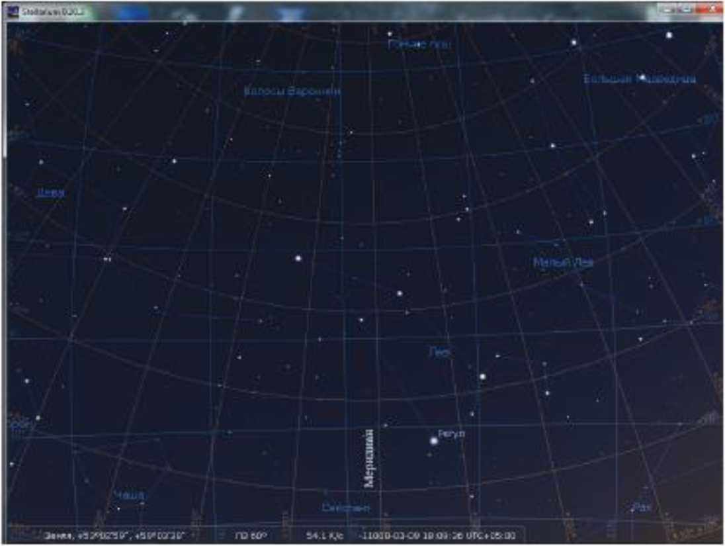

Fig. 7. Looking south, down from right to left, from west to east, the constellations descend: Ursa Major, Hounds, Veronica's Hair, Virgo, Raven.

On this map, west to the right, east to the left, so we look at the constel-



lations descending from right to left.

West of the zenith there is a sign 3-8 "Kim", **which** looks like **a** trapezoid with **an "ear, and** in the sky in that place, at the required time, there was **a** "bucket" of the Big Dipper, which confirms the idea that "buckets", square parts constellations, the ancient people of the Shulgan Tash (Kapova) cave could depict "trapeziums". East of sign 3-8, **but** slightly west of the merid­ian, are the stars of the constelllation Hounds, which can correspond to the sign 3-6 "Deer" - a red-black pattern that looks like a deer. To the south and east, on the meridian, is the Coma of Veronica constellation, whose stars can comes pond to the sign 3-7 "Marat" - a blurred triangular spot, **similar** to the head of an **animal.** Further south **and** east **is** the constellation Virgo, four stars of which can correspond to four signs: 3-4 "Smirnov" - a blurry image, similar to a mammoth or rhinoceros, 3-5 "Tagirovs" - a red, silhouette, poorly distinguishable pattern of a deer, 3- 3 "Lee curve" - a faint image of a curved line, 3-2 1 Roe" - a pale silhouette pattern resembling a roe deer. **The** most southeastern sign is 3-1 "Extreme Mammoth", and it may correspond to the constellation Raven. The other constellations are not **marked** with signs, possibly because they were not visible behind the mountainside.

It may or may not be a coincidence, but there is a 7th day in the Ma­yan calendar, **which is** called Anik [Deer). "The Lord created **this** day. And it was on February 9, 3113 ВC, when the First Father set in motion the Zodiac as his last action in creation. When the stars began to move, the Homed Deer rose from the East for the first time **and** led. **The** high full moon followed on his heels'16, **p. 42].**

On the indicated date February 9 **(in** the StarCalk astro **program** March 4) 3113 BC, it is seen that before the full moon rises, the constellation Virgo rises, **which with** its large stars resembles **an** animal **with** long legs and a high neck with two ho ms, the stars Beta Virgo and the omicron Virgo [7, Fig. &]. (Fig. 8).

Perhaps some tribes kept the images of the named constellations for a long time, and sometimes cultural parallels can be found. For example, there are similar signs of the Dragons among the Chinese, American Ma­yans and among the tribes who painted the sign "Dragon" **in** the **Shulgan** Tash (Kapova) cave at the site of the Dragon constellation. And signs such as "Deer and "Roe" in the Shulgan Tash cave may have a parallel with the interpretation of the 7th day sign "Anik-Deef by the American Mayans at the site of the Virgo constellation. **The** author does not insist on **a** parallel with the Deer, but if such a paraltel arises in some culture, it will be possible to assume that the Virgin was called the Deer in ancient times among the **Altai** Siberian peoples.

<ь 4’

Or.rwtit

46

i

>ir

**■V**

fl«ma

X?l?»ui плш4ц<ние ***f if*** /X

»

\

I

0-

Пир»

*f-*

*KlMla». «к*

J

Взнмй - «

Грн>».^

”Й)» ‘ ,

У-

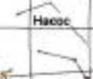

Ламтус

к>

**Fig. 8. The rising of the full moon in the wake of the constellation  
Virgo (the sign of Anik-Deer in the twenty-day long-count calendar  
of the Mayan Calendar [7, Fig. 8].**

**References**

1. *Zvereva, E.S. 20 solar symbols // Secrets of the Maya. Sunny time. [Electronic resource]. - Access: URL: <https://history>. wikireading.ru/316731 (8.05.2021)*
2. *Bauer, V., Dumots, I., Golovin, S. Encyclopedia of Symbols. - M.: JSC “KRON-press", 1995. - 502 P.*
3. *Kaurov, E.N. Constellation of the Dragon: an archaic system of as­tronomical observations //Dragon and Zodiac. - M.: Astronomical Society. Commission for Paleoastronomy EAAS, 1997. P 5-50.*
4. *Dragon (constellation). [Electronic resource]. - Access: URL: htt- ps://ru. Wikipedia. org/wiki/%D0% 94 %D 1 %&0%D0% B0%D0%BA %D0% BE %DO% BD_J% D1%81%D0%B E%D 0% В 7%D 0% B2 %DO% B5%D0% В 7% D0%B4%D0% B8%D0%B* 5J
5. *Lyakhnitsky Yu.S., Minnikov, O.A., Yushko, A. A. Drawings and signs of the Shulgan Tash (Kapoval cave. - Ufa: Kitapf 2013. - 288 P.*

*8. Keizer R. Secrets of the Mayan and Aztec priests. Predictions for the millennium: Transt. from Eng. -* ML: WecAe, 1997. - *544 P.*

*7. Twenty signs of the Mayan Long Count among the constellations //Ar­chaeoastronomy and Ancient Technologies 1(1), 2013. P. 26-52. [Electron­ic resource]. -* Access: *URL <https://histofy.wikireading.fu/316731http://> aaatec.org/documents/article/po1.pdf (date 1.10.2013).*